ASSIGNMENT FINAL REPORT

Qualification | Pearson BTEC Level 5 Higher National Diploma in Computing
Unit number and title | Unit 18: Discrete Maths
Submission date |  | Date Received 1st Submission
Re-submission Date |  | Date Received 2nd Submission
Student Name |  | Student ID
Class |  | Assessor name
Plagiarism
Plagiarism is a particular form of cheating. Plagiarism must be avoided at all costs and students who break the rules, however innocently, may be penalised. It is your responsibility to ensure that you understand correct referencing practices. As a university level student, you are expected to use appropriate references throughout and keep carefully detailed notes of all your sources of materials for material you have used in your work, including any material downloaded from the Internet. Please consult the relevant unit lecturer or your course tutor if you need any further advice.
Student Declaration
I certify that the assignment submission is entirely my own work and I fully understand the consequences of plagiarism. I declare that the work submitted for assessment has been carried out without assistance other than that which is acceptable according to the rules of the specification. I certify I have clearly referenced any sources and any artificial intelligence (AI) tools used in the work. I understand that making a false declaration is a form of malpractice.
 |  | Student’s signature

Grading grid
P1 | P2 | P3 | P4 | M1 | M2 | D1 | D2

ASSIGNMENT GROUP WORK
Qualification | Pearson BTEC Level 5 Higher National Diploma in Computing
Unit number and title | Unit 18: Discrete Maths
Submission date |  | Date Received 1st submission
Re-submission Date |  | Date Received 2nd submission
Group number: | Student names & codes | Final scores | Signatures
Class |  | Assessor name
Plagiarism
Plagiarism is a particular form of cheating. Plagiarism must be avoided at all costs and students who break the rules, however innocently, may be penalised. It is your responsibility to ensure that you understand correct referencing practices. As a university level student, you are expected to use appropriate references throughout and keep carefully detailed notes of all your sources of materials for material you have used in your work, including any material downloaded from the Internet. Please consult the relevant unit lecturer or your course tutor if you need any further advice.
Student Declaration
I certify that the assignment submission is entirely my own work and I fully understand the consequences of plagiarism. I declare that the work submitted for assessment has been carried out without assistance other than that which is acceptable according to the rules of the specification. I certify I have clearly referenced any sources and any artificial intelligence (AI) tools used in the work. I understand that making a false declaration is a form of malpractice.

P5 | P6 | P7 | P8 | M3 | M4 | D3 | D4

OBSERVATION RECORD
 | Student
 | Description of activity undertaken
 | Assessment & grading criteria
 | How the activity meets the requirements of the criteria
 | Student signature: |  |  | Date:
 | Assessor signature: |  |  | Date:
 | Assessor name:
❒ Summative Feedback: ❒ Resubmission Feedback:

Grade: |  |  | Assessor Signature: |  |  | Date:
Internal Verifier’s Comments:
Signature & Date:

INTRODUCTION

INTRODUCTION 8
ACTIVITY 1 9
Part I. Stick in mind that represents the largest digits in your ID. 9
Part II. Keep in mind that represents the largest digits in your ID. 10
ACTIVITY 2 14
Part I. Discuss two notable instances of binary trees, providing both quantitative and qualitative analyses. 14
Part II. Stick in mind that represents the largest digits in your ID. 14
Part III. Does the following graph have a Hamilton path? If so, find such a path. If it does not, give an argument to show why no such path exists. 15
Part IV. Construct a proof of the Five Color Theorem. 16
ACTIVITY 3 17
Part I. Discuss the utilization of Boolean Algebra in addressing binary problems encountered in two diverse real-world domains and the practical applications therein. 17
Part II. 17
Part III. Simplify the following Boolean expressions. 18
Part IV. Build a circuit using OR gates, AND gates, and inverters that produces an output of 1 if a decimal digit, encoded using a binary coded decimal expansion, is divisible by 3, and an output of 0 otherwise. Identify the representation of the Boolean function that has the output value. 19
ACTIVITY 4 20
Part I. 20
Part II. 20
Part III. 21
Part IV. Prepare a fifteen minutes presentation that explains an application of group theory in computer sciences. 22

Student ID: BH00246
a=4 b = 6

ACTIVITY 1

Part I. Stick in mind that 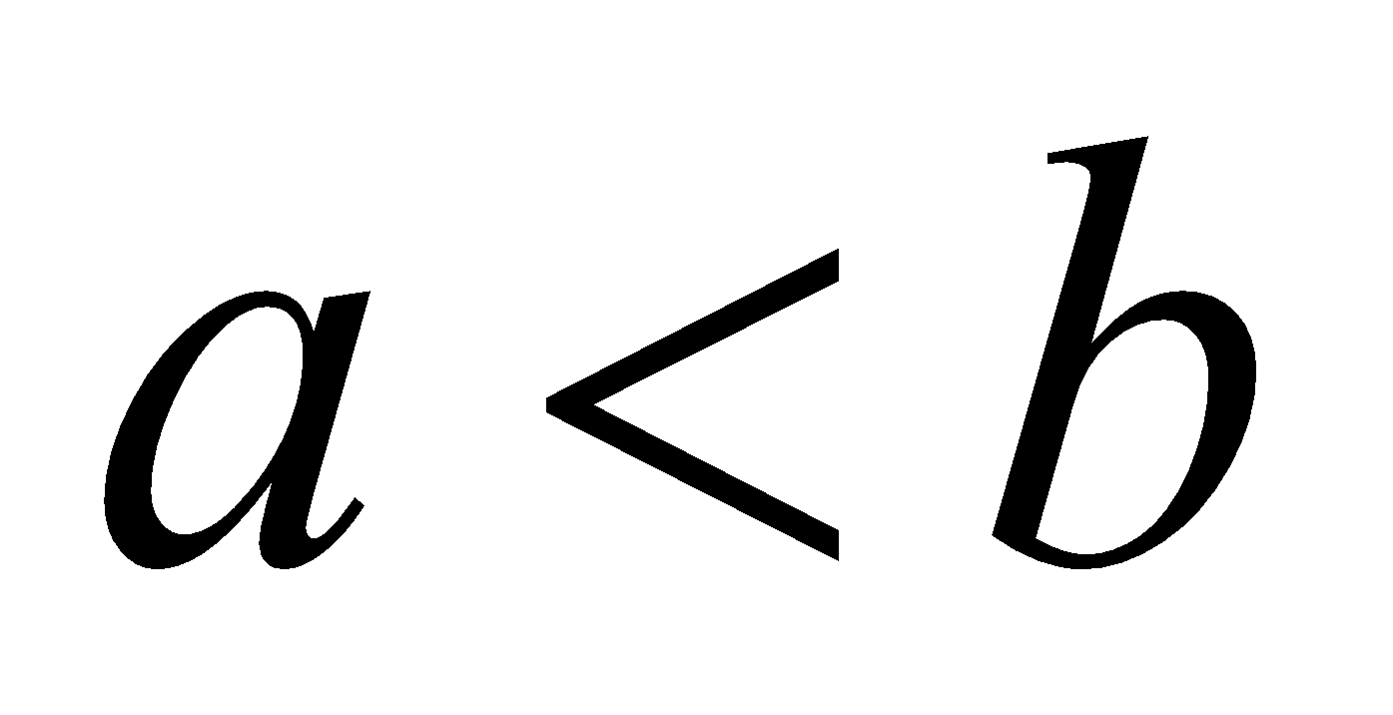represents the largest digits in your ID.
- Let and be two non-empty finite sets. Assume that cardinalities of the sets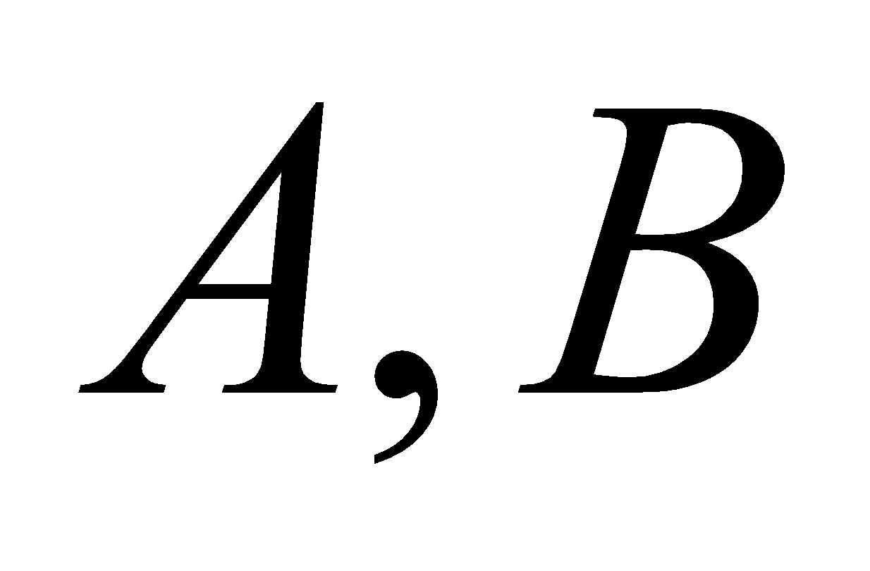 and 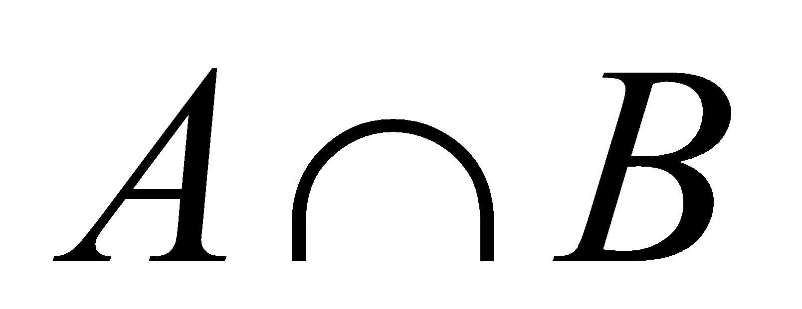are 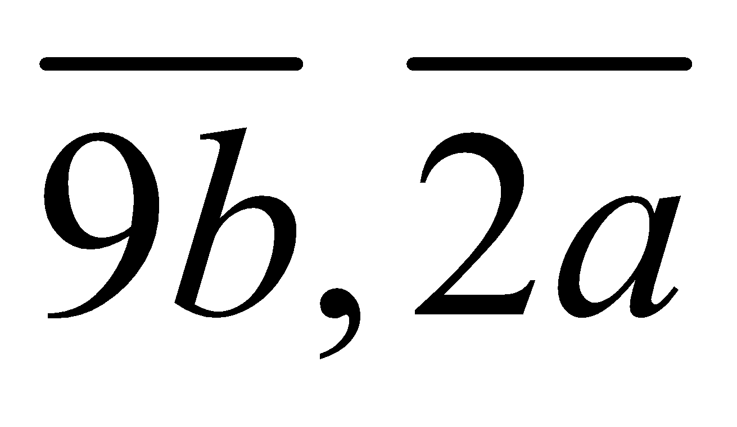 and 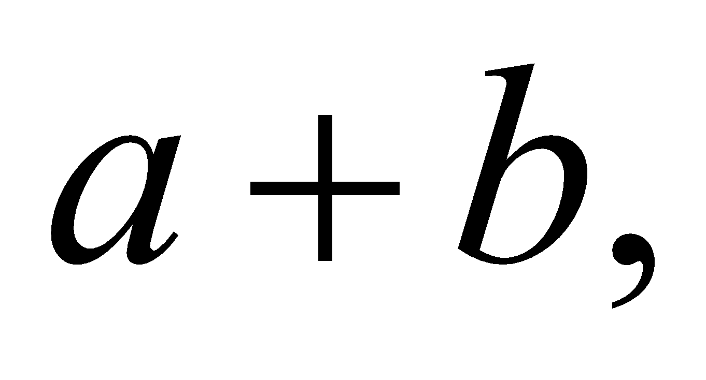respectively. Determine the cardinality of the set 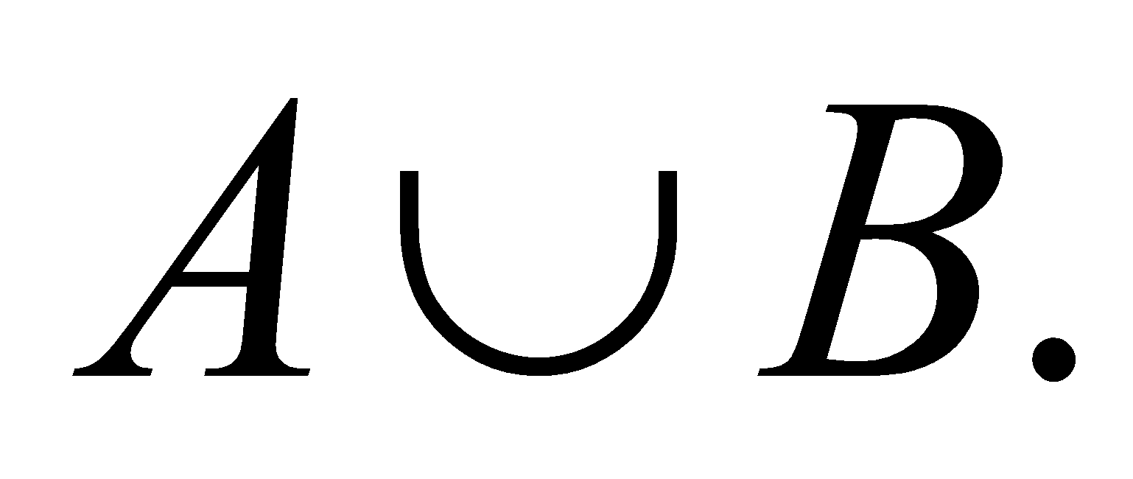
_{ANSWER:}
…………………………………………………………………………………………………………………………………………..

- Suppose 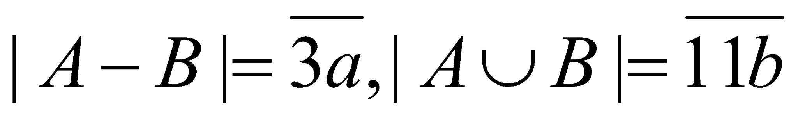 and 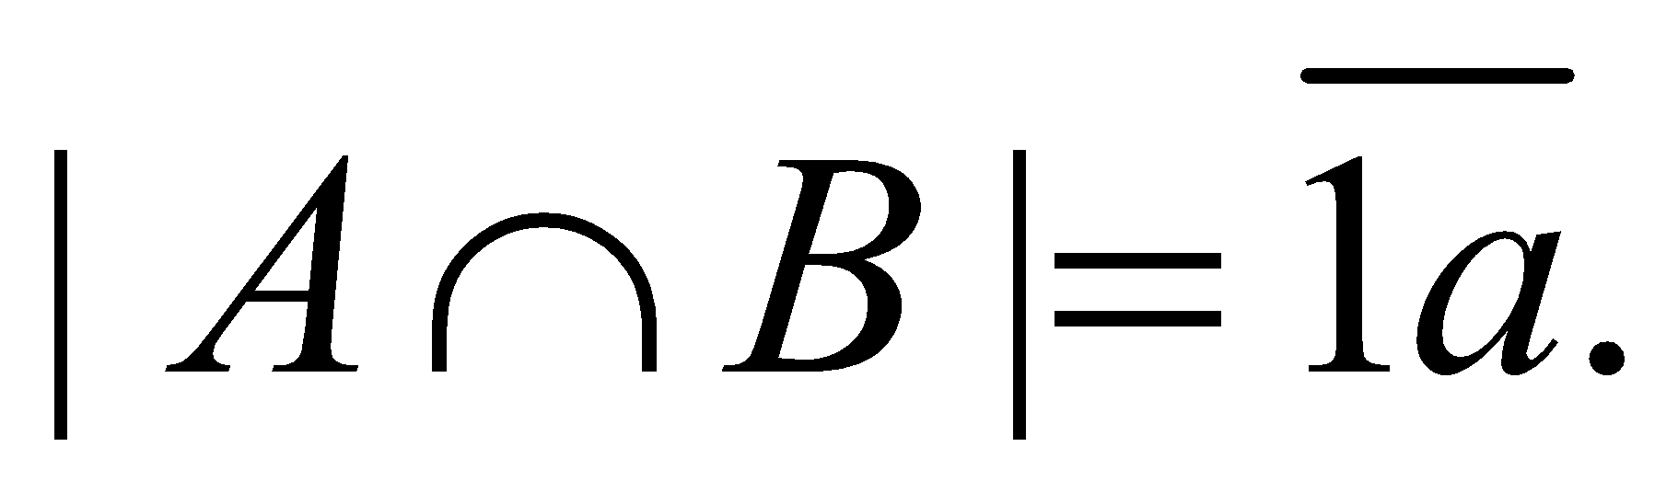 Determine 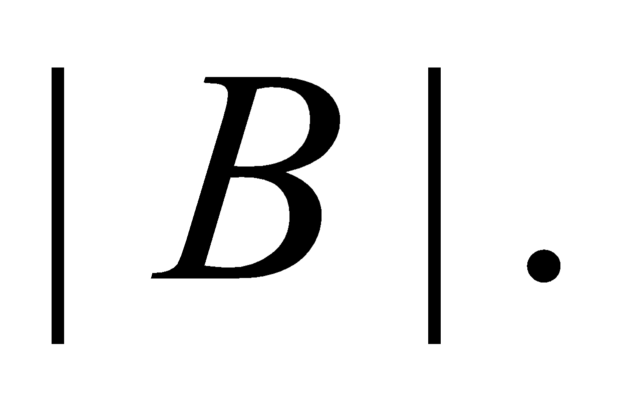
_{ANSWER:}
…………………………………………………………………………………………………………………………………………..

- At a local market, there are 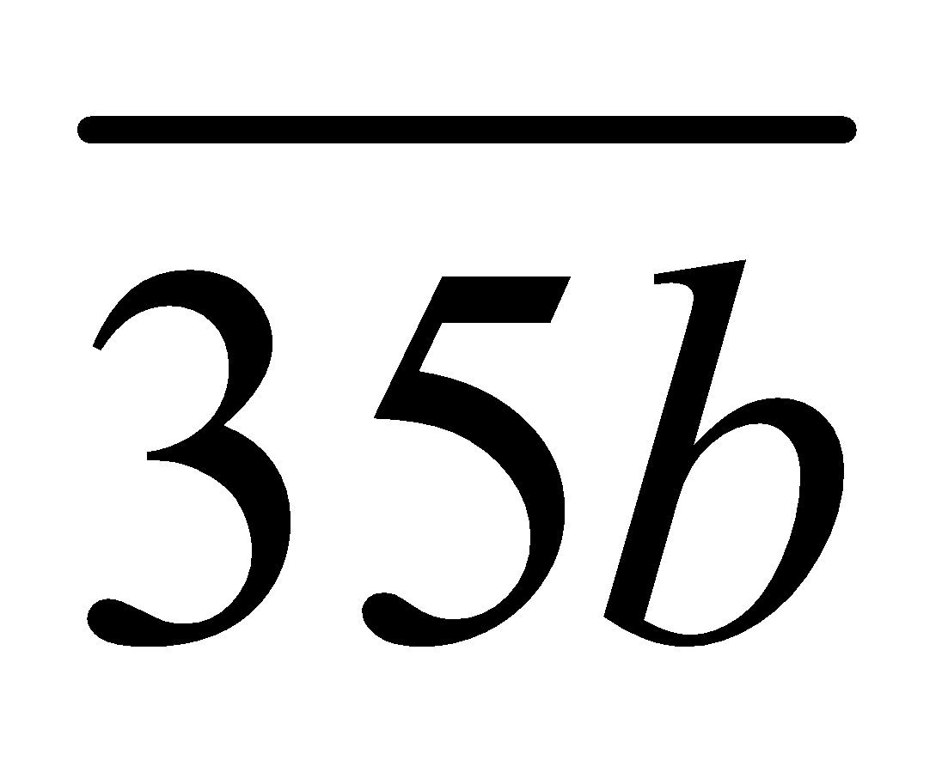 customers. Suppose 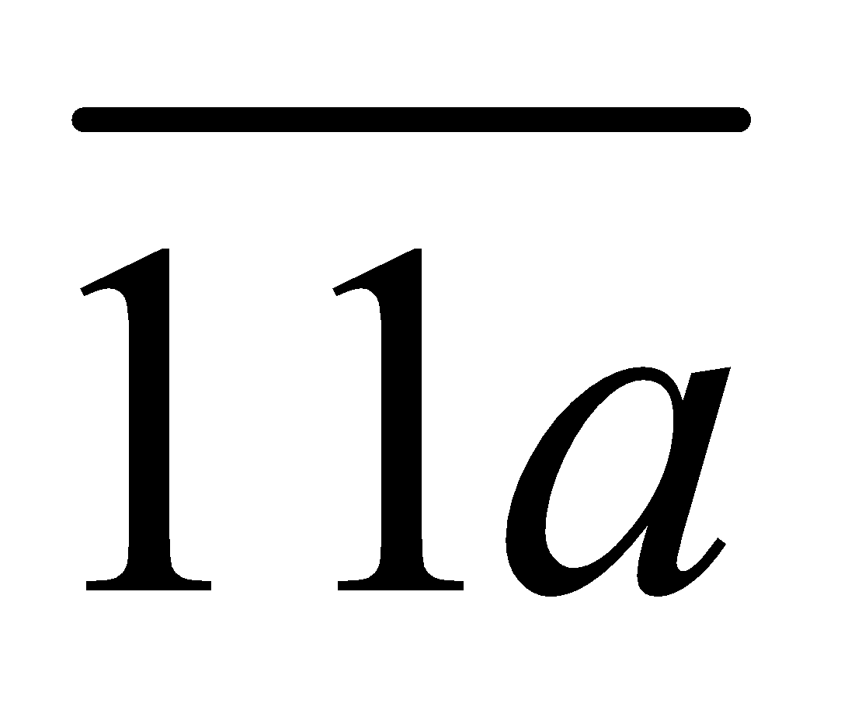 have purchased fruits, 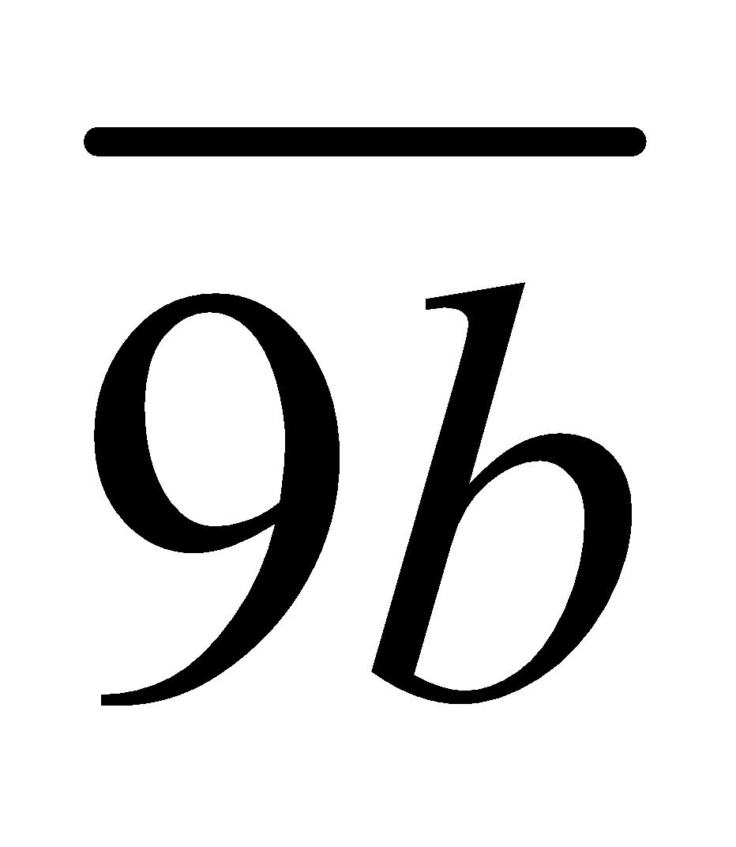 have purchased vegetables, 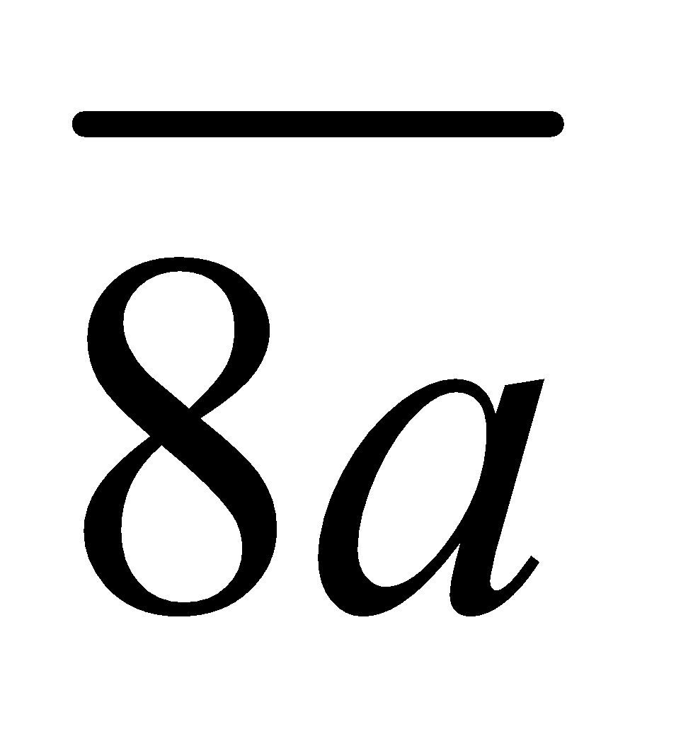 have purchased bakery items, 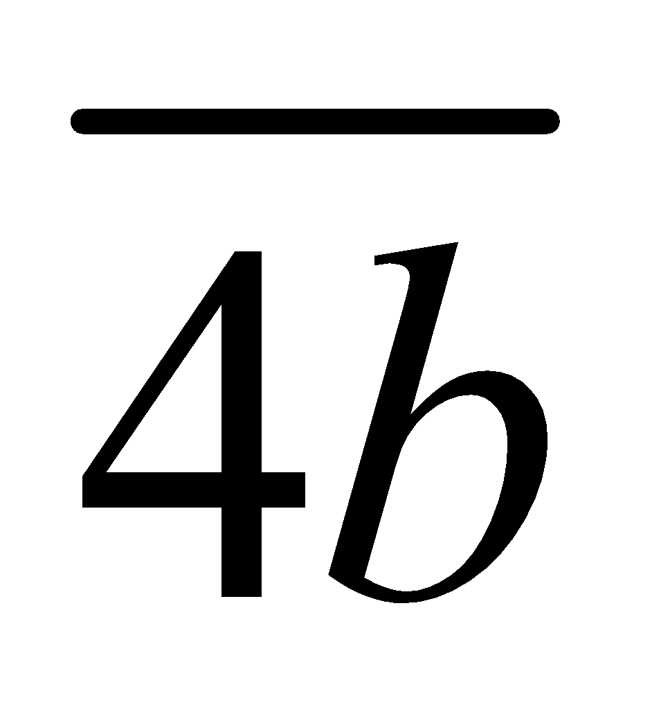have purchased both fruits and vegetables, 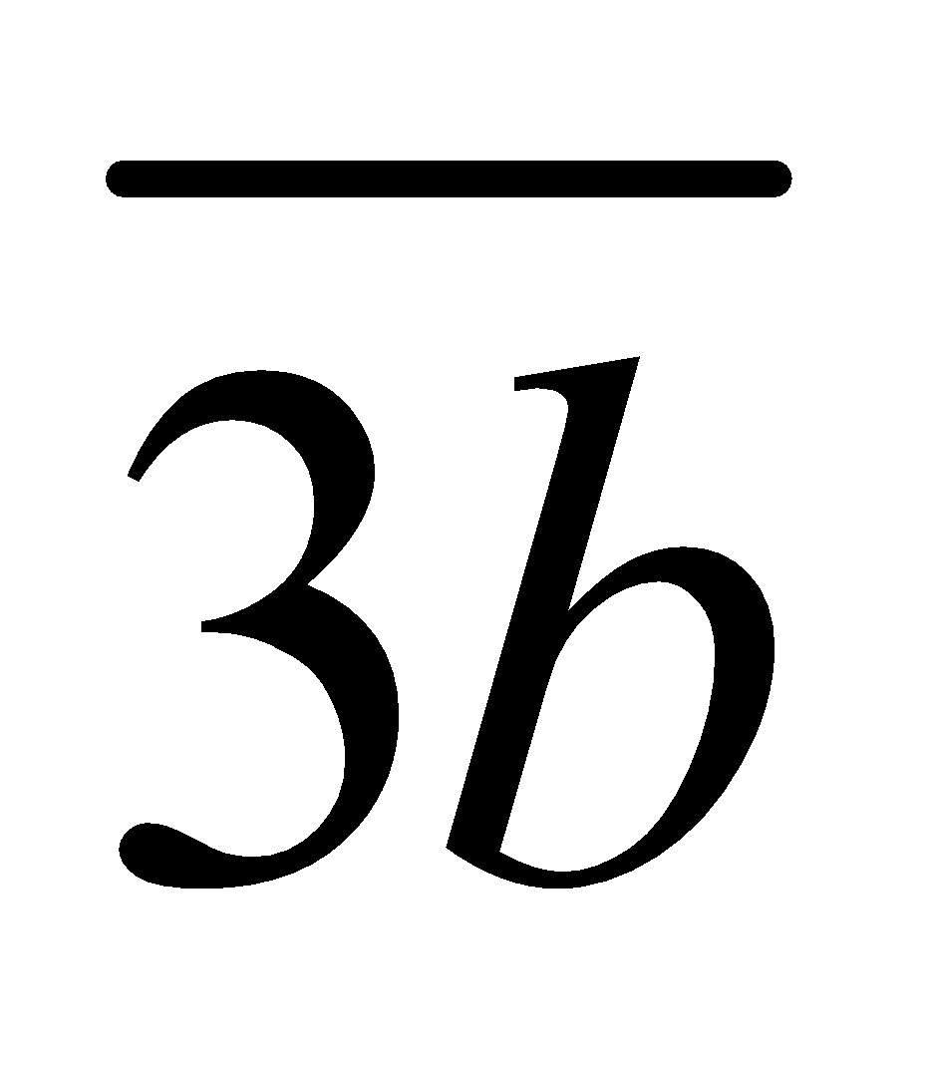 have purchased both vegetables and bakery items, 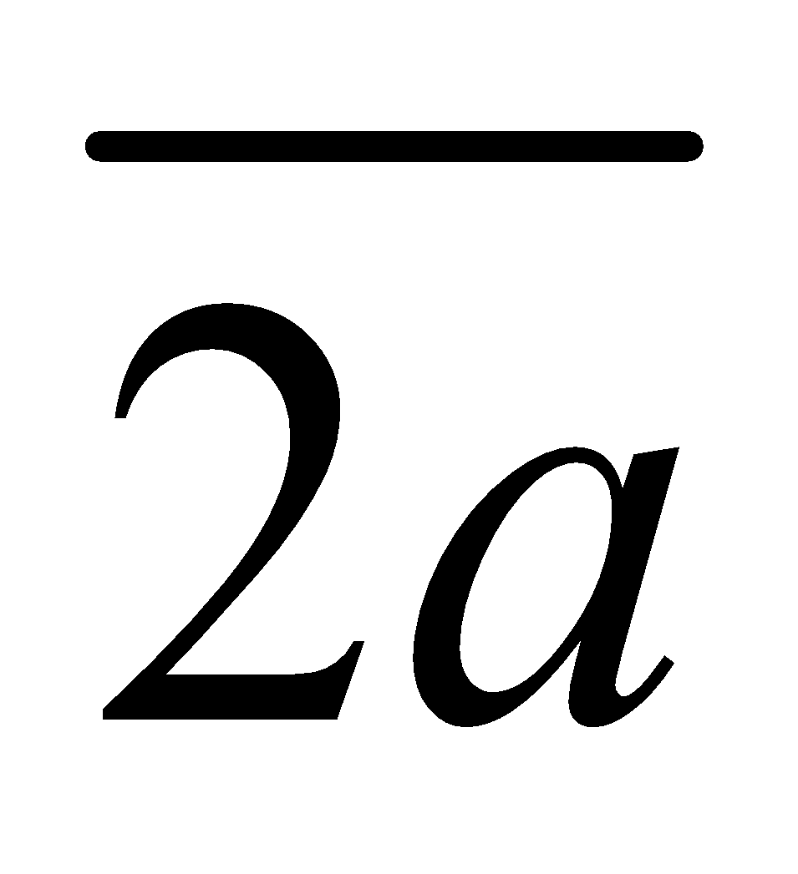 have purchased both fruits and bakery items, and 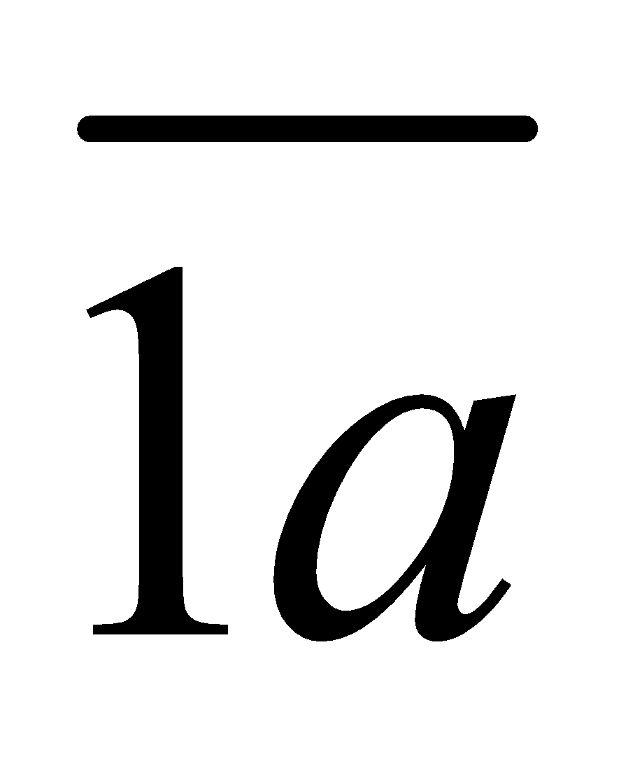 have purchased all three categories. How many customers have not purchased anything?
_{ANSWER:}
…………………………………………………………………………………………………………………………………………..

Part II. Keep in mind that represents the largest digits in your ID.

List the bag of prime factors for each of the provided numbers.
- 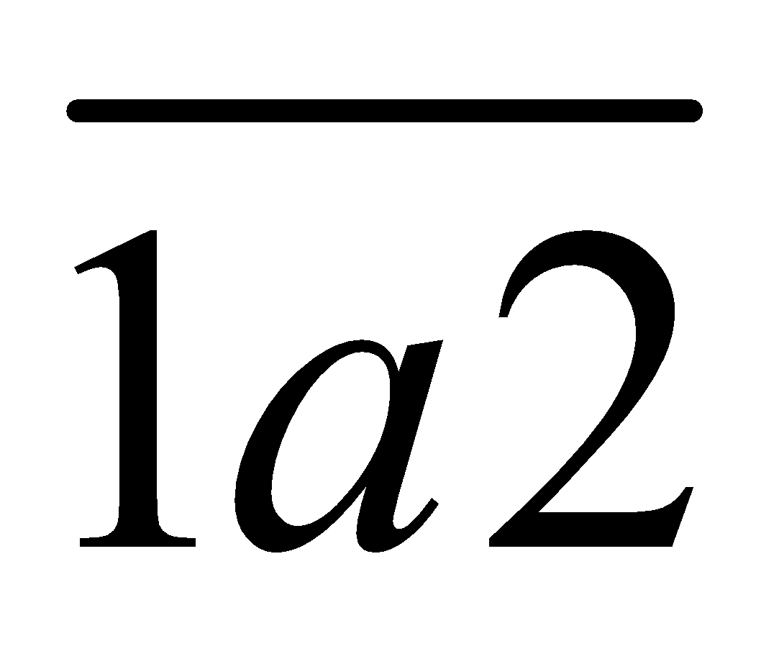
_{ANSWER:}
…………………………………………………………………………………………………………………………………………..

- 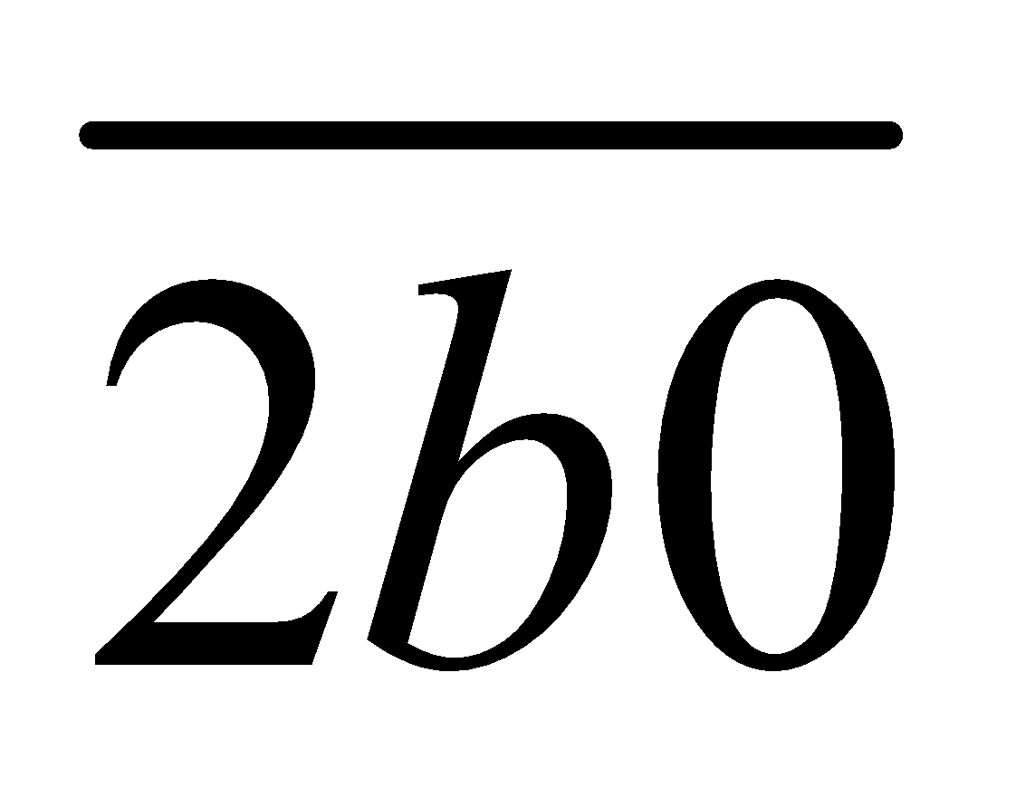

_{ANSWER:}
…………………………………………………………………………………………………………………………………………..

2. Find the cardinalities of
a) each of the aforementioned bags.
_{ANSWER:}
…………………………………………………………………………………………………………………………………………..

b) the intersection of the aforementioned bags.
_{ANSWER:}
…………………………………………………………………………………………………………………………………………..

c) the union of the aforementioned bags.
_{ANSWER:}
…………………………………………………………………………………………………………………………………………..

d) the difference of the aforementioned bags.
_{ANSWER:}
…………………………………………………………………………………………………………………………………………..

Part III. Bear in mind that represents the largest digits in your ID.
- Ascertain whether the given functions are invertible. If they are, identify the rule for the inverse function 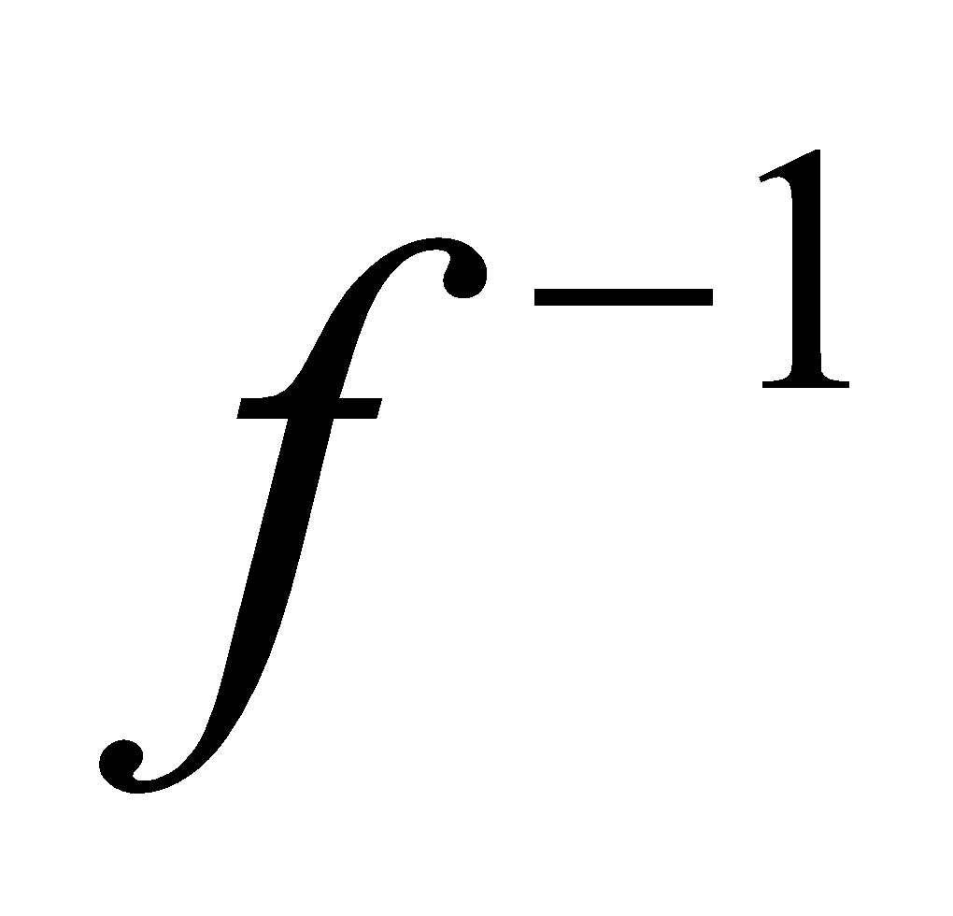.
- 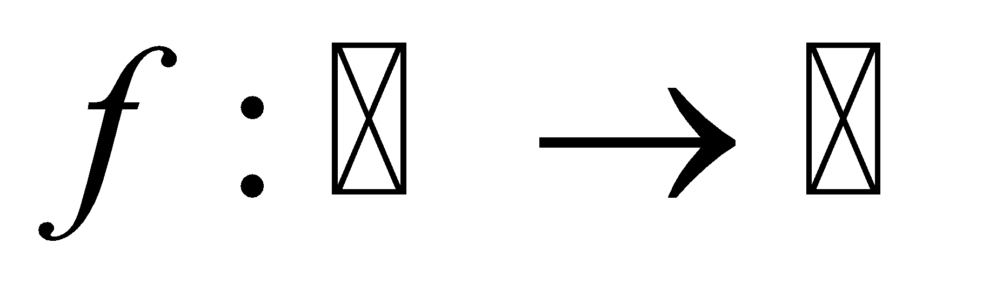 with 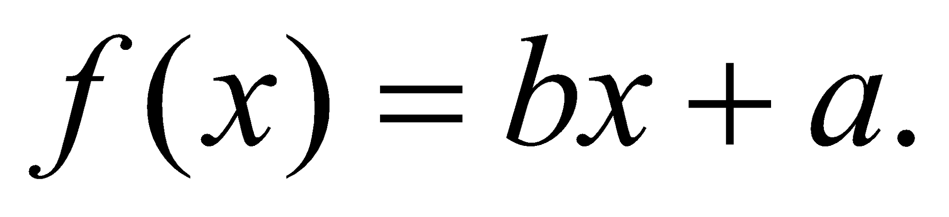
_{ANSWER:}
…………………………………………………………………………………………………………………………………………..

- 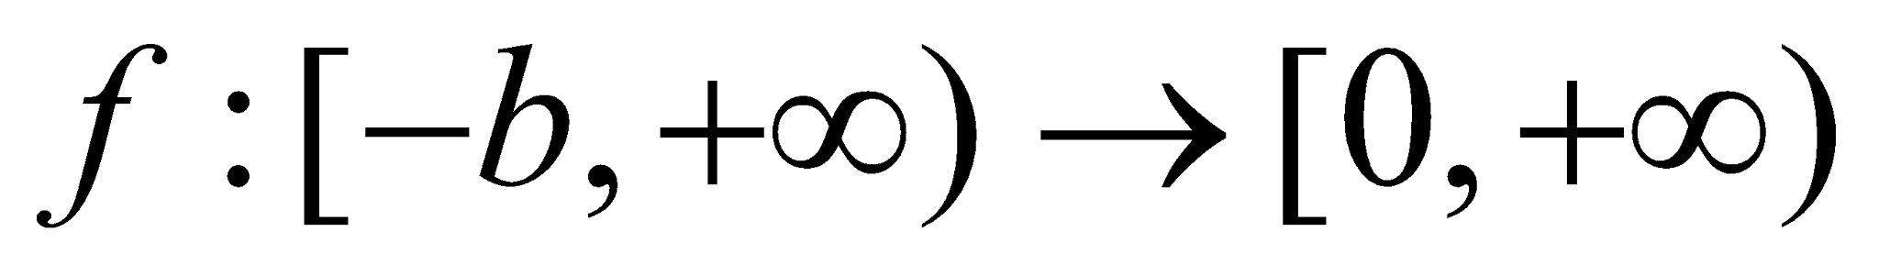 with 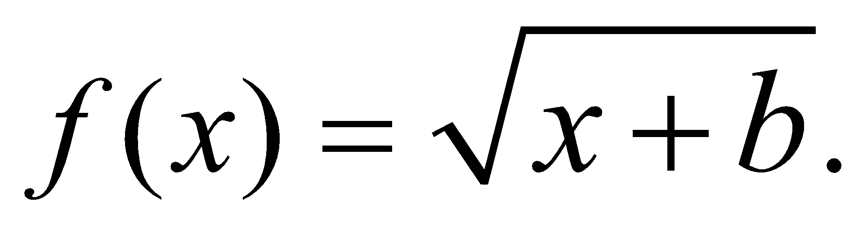
_{ANSWER:}
…………………………………………………………………………………………………………………………………………..

2. Let 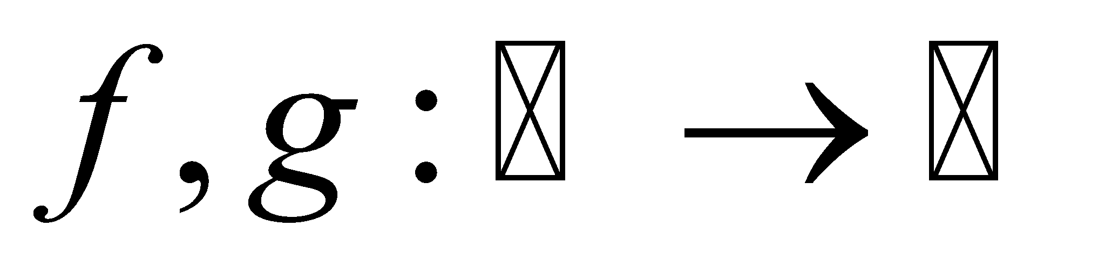be defined as 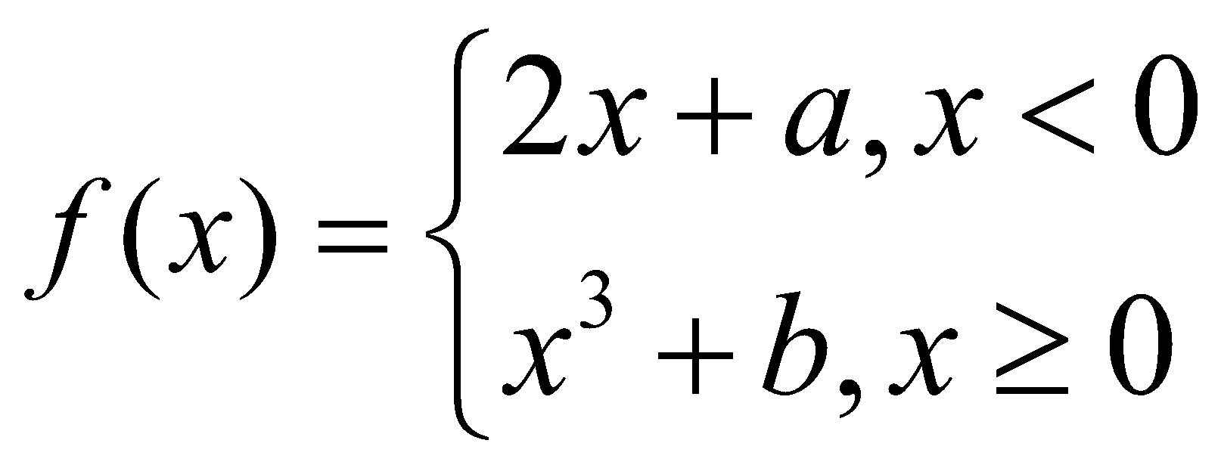 and 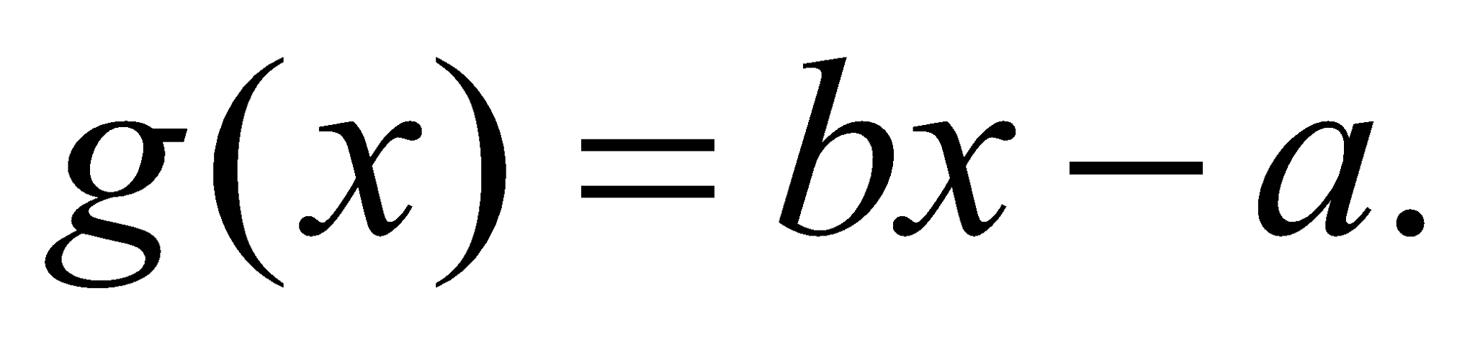 Find 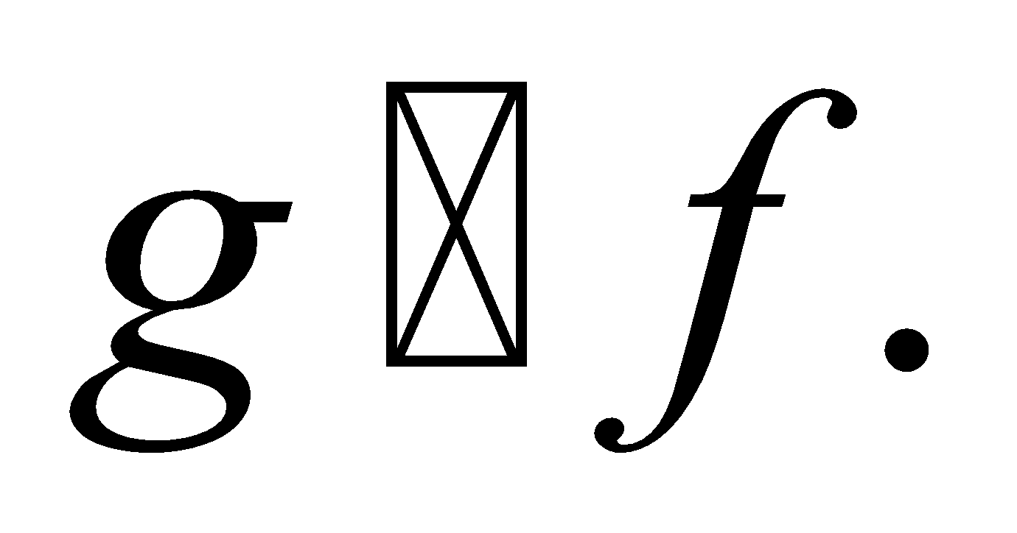

_{ANSWER:}
…………………………………………………………………………………………………………………………………………..

Part IV. Show that if  and are sets, then 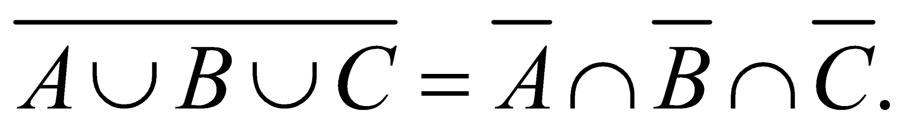
1. Demonstrate that each side is a subset of the other side.

_{ANSWER:}
…………………………………………………………………………………………………………………………………………..

2. Verify the equality using a membership table.

_{ANSWER:}
…………………………………………………………………………………………………………………………………………..

ACTIVITY 2

Part I. Discuss two notable instances of binary trees, providing both quantitative and qualitative analyses.
_{ANSWER:}
…………………………………………………………………………………………………………………………………………..

Part II. Stick in mind that  represents the largest digits in your ID.
1. State Dijkstra’s Algorithm in an undirected graph.
_{ANSWER:}
…………………………………………………………………………………………………………………………………………..

2. Apply Dijkstra’s algorithm to determine the shortest path length between vertices and  in the provided weighted graph.
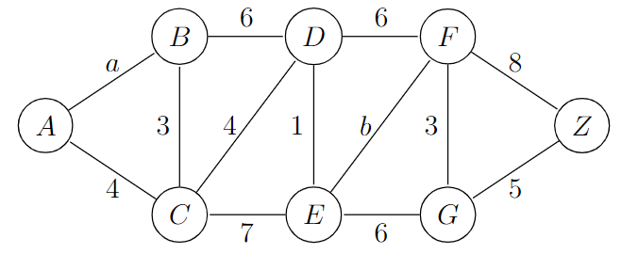

_{ANSWER:}
…………………………………………………………………………………………………………………………………………..

Part III. Does the following graph have a Hamilton path? If so, find such a path. If it does not, give an argument to show why no such path exists.
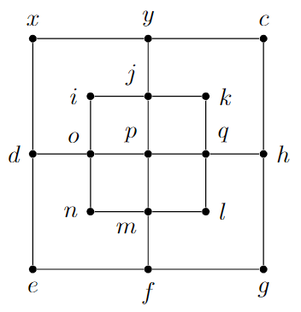

_{ANSWER:}
…………………………………………………………………………………………………………………………………………..

Part IV. Construct a proof of the Five Color Theorem.
_{ANSWER:}
…………………………………………………………………………………………………………………………………………..

ACTIVITY 3

Part I. Discuss the utilization of Boolean Algebra in addressing binary problems encountered in two diverse real-world domains and the practical applications therein.

Part II.
1. Develop the truth table and derive the corresponding Boolean equation for each of the following scenarios.
a) "In a secure facility, if the access card is swiped OR the correct PIN is entered AND the security system is NOT in maintenance mode, then the door should unlock."
_{ANSWER:}
…………………………………………………………………………………………………………………………………………..

b) "For a computer to successfully log in, either a valid username and password combination must be entered OR a security token must be provided, but not both."
_{ANSWER:}
…………………………………………………………………………………………………………………………………………..

2. Generate a truth table for the provided Boolean expression.
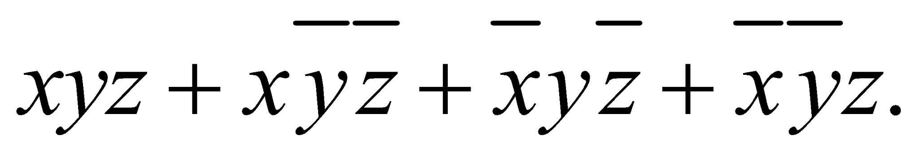
_{ANSWER:}
…………………………………………………………………………………………………………………………………………..

Part III. Simplify the following Boolean expressions.
1. 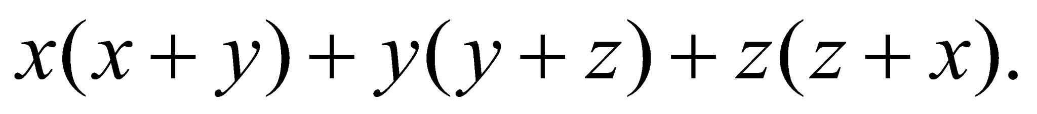
_{ANSWER:}
…………………………………………………………………………………………………………………………………………..

2. 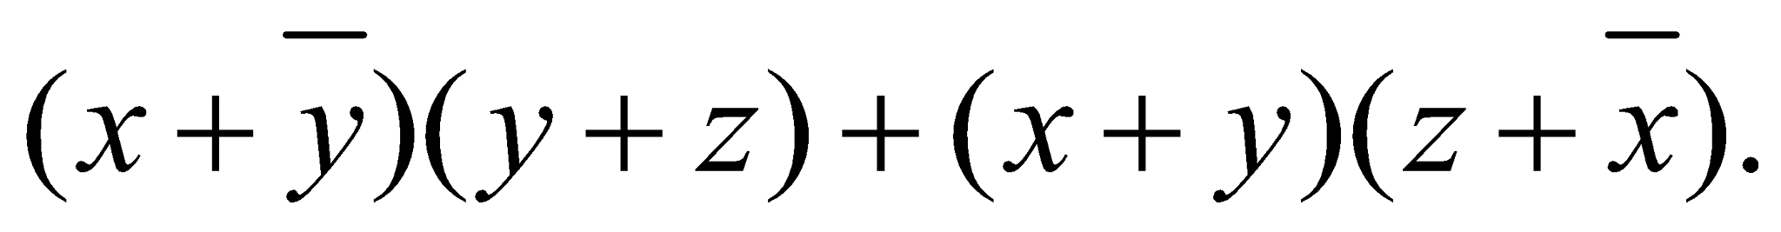
_{ANSWER:}
…………………………………………………………………………………………………………………………………………..

3. 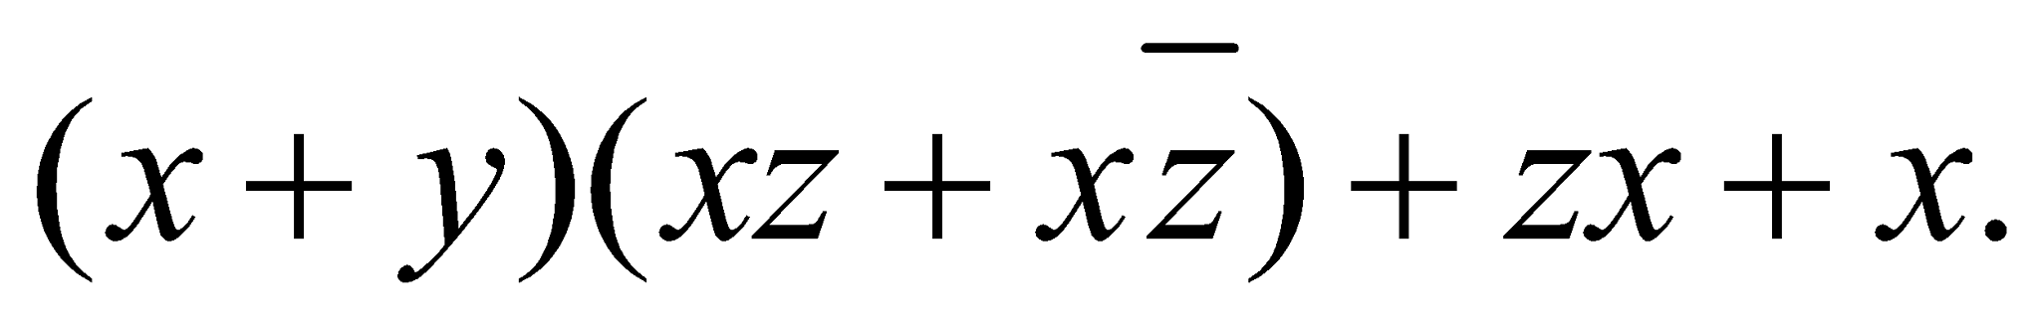
_{ANSWER:}
…………………………………………………………………………………………………………………………………………..

4. 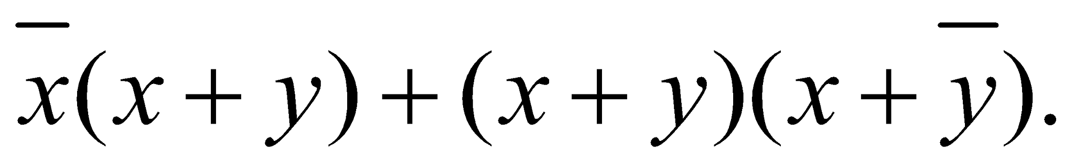
_{ANSWER:}
…………………………………………………………………………………………………………………………………………..

Part IV. Build a circuit using OR gates, AND gates, and inverters that produces an output of 1 if a decimal digit, encoded using a binary coded decimal expansion, is divisible by 3, and an output of 0 otherwise. Identify the representation of the Boolean function that has the output value.

_{ANSWER:}
…………………………………………………………………………………………………………………………………………..

ACTIVITY 4

Part I.
- Explain the attributes of various binary operations executed within a common set.
- Check whether the operations applied to pertinent sets qualify as binary operations.
- Subtraction on set of natural numbers.
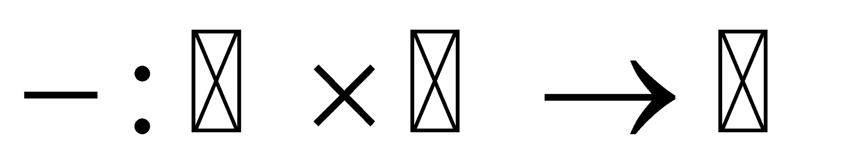
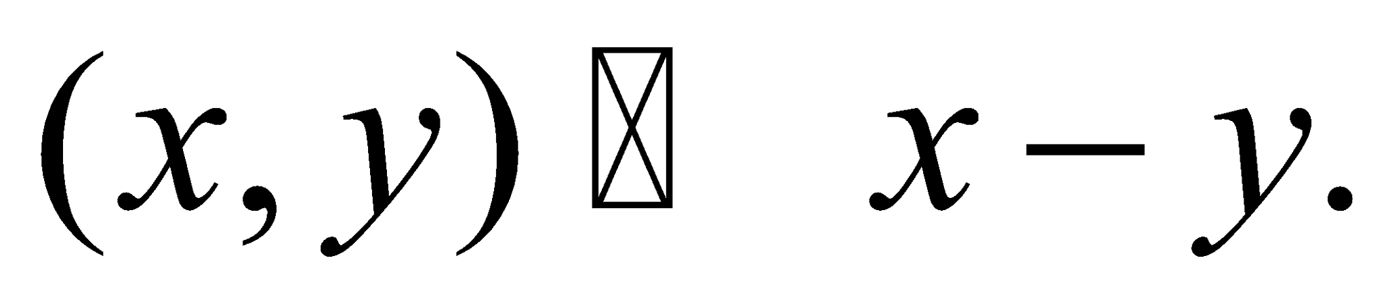

_{ANSWER:}
…………………………………………………………………………………………………………………………………………..

- Exponential operation on set integers.
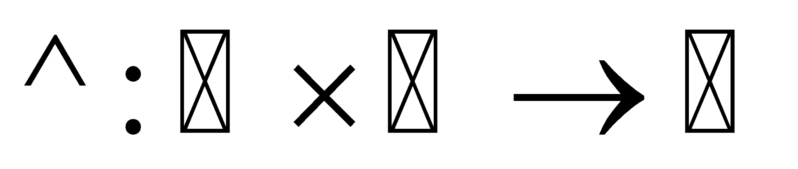
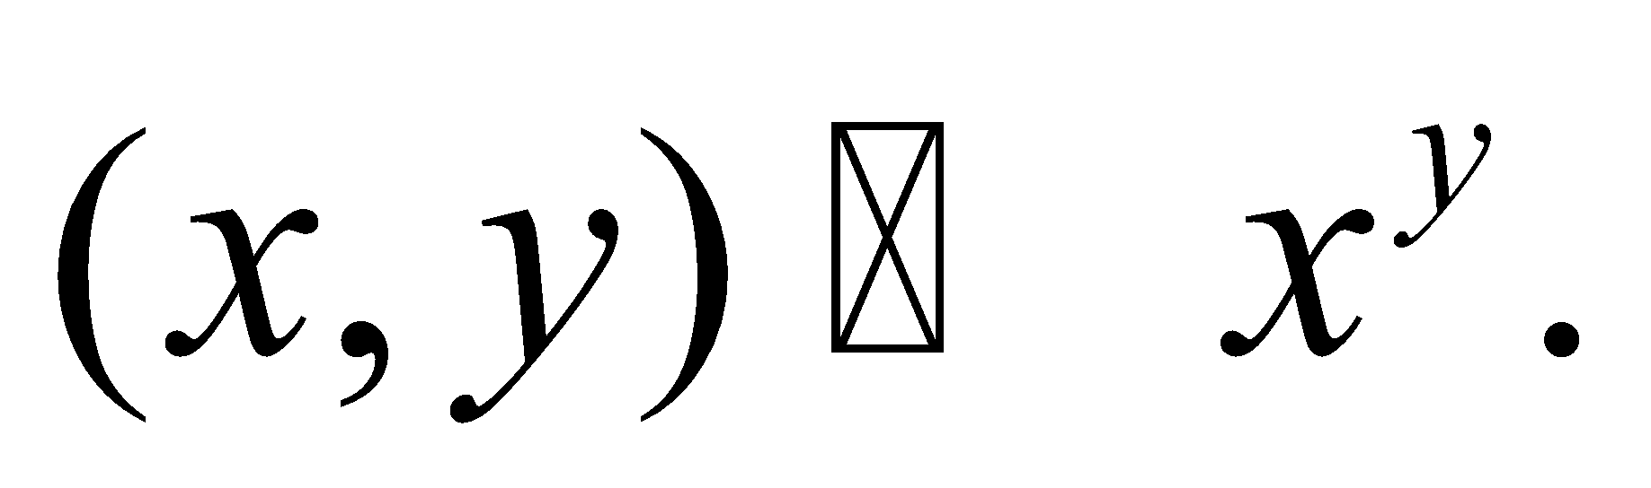

_{ANSWER:}
…………………………………………………………………………………………………………………………………………..

Part II.
1. Construct the operation tables for group  with orders 1, 2, 3, and 4, utilizing the elements 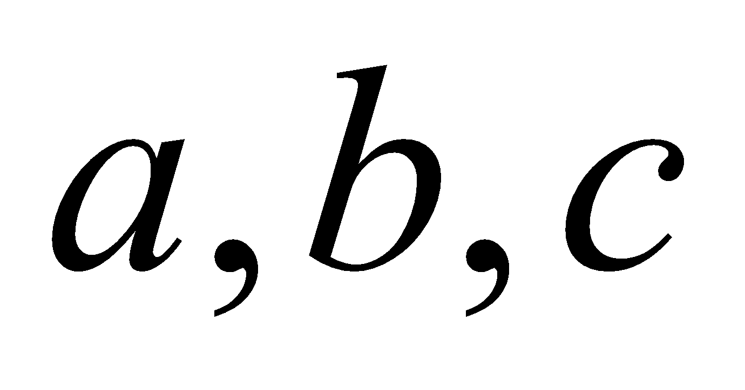 and 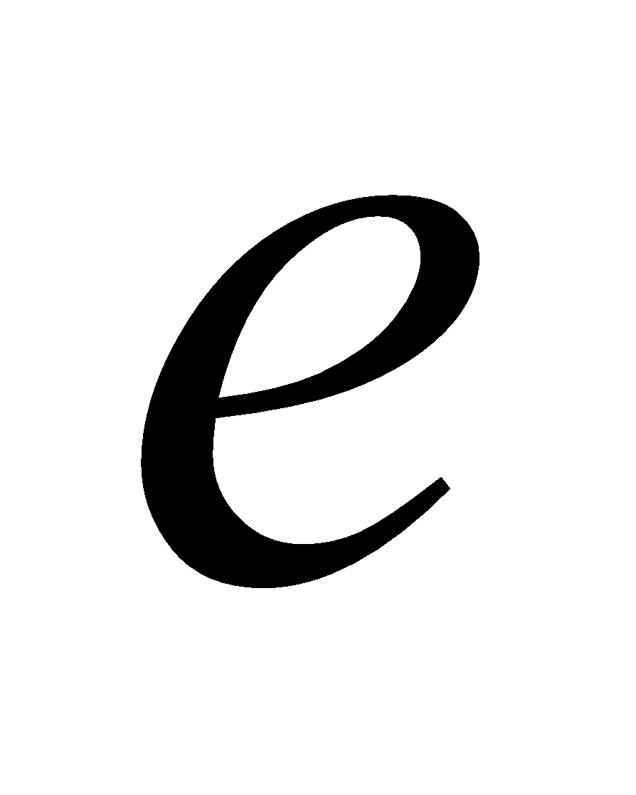 as the identity element in a suitable manner.
_{ANSWER:}
…………………………………………………………………………………………………………………………………………..

2. State the Lagrange’s theorem of group theory. Using this theorem to discuss whether a group  with order 4 can be a subgroup of a group G with order 9 or not. Provide a clear exposition of the reasons.
_{ANSWER:}
…………………………………………………………………………………………………………………………………………..

Part III.
1. Check whether the set 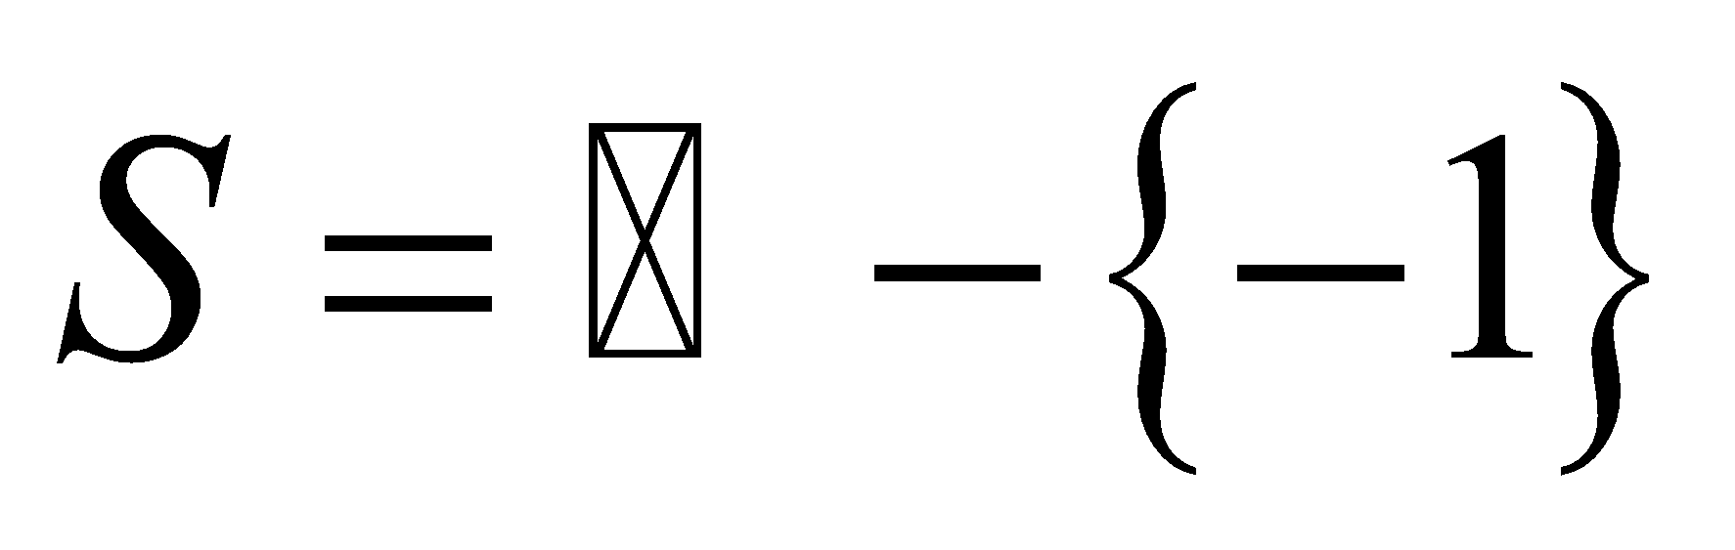is a group under the binary operation ∗ defined as 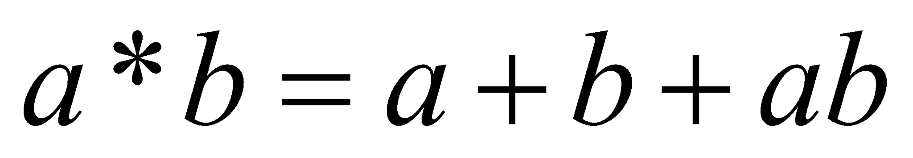 for any 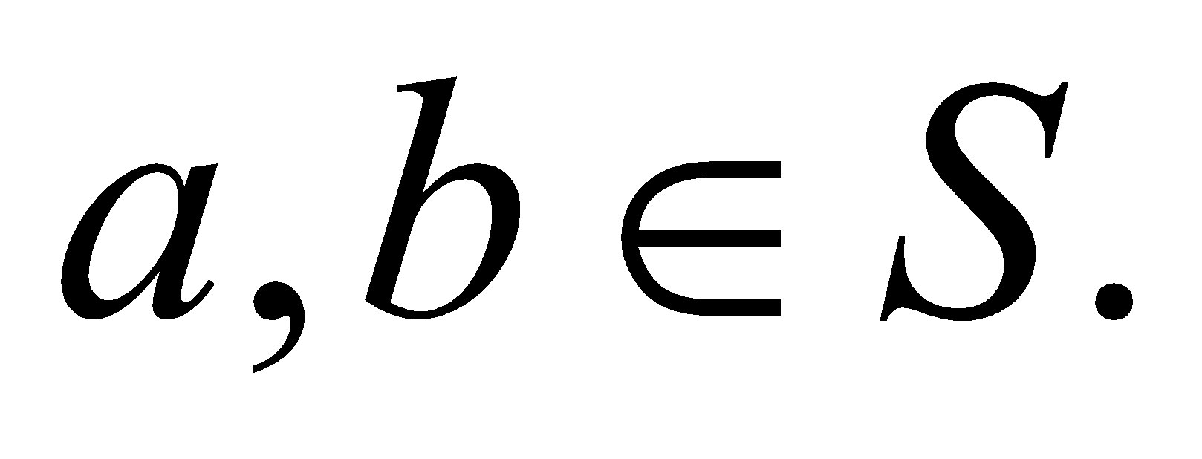
_{ANSWER:}
…………………………………………………………………………………………………………………………………………..

2. Express the connection between the order of a group and the quantity of binary operations that can be defined on that set. Apply to answer the question "What is the total number of binary operations that can be defined on a set containing 3 elements?"
_{ANSWER:}
…………………………………………………………………………………………………………………………………………..

Part IV. Prepare a fifteen minutes presentation that explains an application of group theory in computer sciences.

_{ANSWER:}
…………………………………………………………………………………………………………………………………………..

